**KangaPages Business plan**

**CHAPTER 1: BUSINESS DESCRIPTION**

**1.1 Business Sponsors**

The owner of this business proposal is Lewis Kariuki. A Information Science student with a focus specialization in Informatics. Has additional certification in graphic design awarded by Canva , Responsive Website development from Freecode camp, Data Science certification and Business Intelligence from IBM Kenya. From those certification which were provided after proposed projects and exam they provide essential skills to provide this service. Some of the services include Responsive website design, data analysis, Business Intelligence and Computer Literacy ensuring a steady increasing learning curve to ready made software systems that are integrated to those website.

**1.2 Business Name**

KangaPages

**1.3 Business Location and Address**

The location of the business is located in the Star Shopping Mall in Nairobi CBD along Tom Mboya St, Nairobi ; <https://maps.app.goo.gl/ppJJpHWbbZbQRDhr6>.

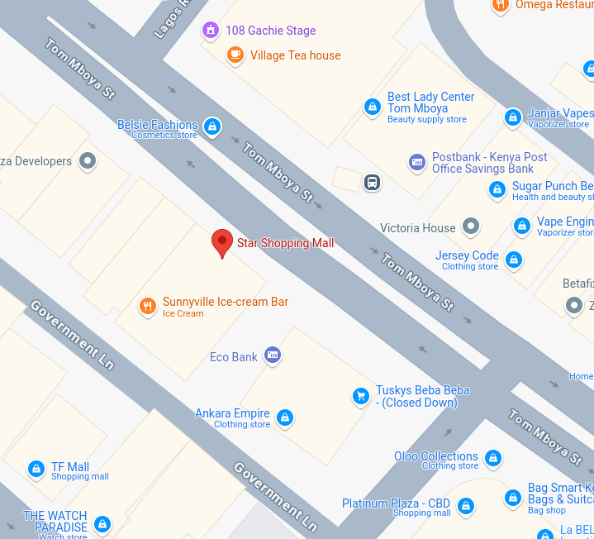The postal code address; **P.O. Box 10097, Nairobi, 00100, Kenya. Telephone Number 0746668098**

**1.4 Form of Business Ownership**

**KangaPages is a private limited company where Lewis is currently the main staff with the sight of future expansion of gathering possible future undiscovered talent who are identified early and diligently trained to leveraging software both proprietor and open source technology like for example Canva for graphics design, Word Press for website creation and content management, excel and Power BI fo data analysis and data visualization. 30% of the capital budget to go to purchase full enterprise versions of the required software, 40% to go to server storage purchase and maintenance and 20% marketing 10% daily operations. The minimum start up capital to be invested is khs 320,000. And after the initial startup the maintenance capital is an average of khs 140,000 per month. The initial capital could be gathered from Friends and families, financial loans from institutions like banks, venture capitalist, angle investors**

****1.5 Type of Business****

**Developing custom website tailor made for both business and individuals that act as you own digital self image to the world. Using a Software as a Service Business model (Saas). The proposed business would develop and maintain custom website that have your own domain name for example; Client name: John Doe, Website name: www.johndoe.co.ke. They are tailor made to perform several functions that would increase the value image of a business or individual thus in turn increase the traffic flow of potential loyal customers to seek you the client as the go to for a particulate service or good to purchase. The website act as a social media management tool that links all the clients accounts like; LinkedIn, GitHub, Tiktok, YouTube, X, Pintrest etc. The website act as a repository for all you achievements from the small ones to the big ones. Using data analysis tools in the website you the client would be presented with a dashboard that has stylish easy to read and understand data visualizations graphs that could help you track trends on potential users that have a higher probability to be loyal customers that have a higher potential to help you value grow. Provide you with possible future sight from predictive analysis of you identified competitors and marketing needs that have not yet been identified that you could identify, solve them and gain a higher profit margins.**

****1.6 Product(s) Service(s)****

**The product that the business are offering is a custom website tailor made for both business and individuals. Qualitative and quantitative research data collection and analysis through dashboard that has stylish, easy to read and understand data visualizations graph providing you. Using the Software as a Service Business model (Saas) the business would develop website that would provide clients social media management, predictive analysis of identifying potential high value, loyal users to seek you as the go to business or individual for a particular good or services. By securing our products that would provide you with the stated service business would gain a competitive edge against their competition from increased traffic flow of loyal customers to you business and ‘future sight’ brought by predictive analysis. To individuals a custom website would act as a social media management tool that would ensure a skyrocket of ones image value in the community you are in. Having your own dedicated website with you custom domain name that offers predictive user analysis of potential gaps to ones social profile.**

****1.7 Justification of Business Opportunity****

**‘In life pursuer what you love and seek freedom.’ This is a saying that I was advised a while back. From the love of technological development and innovation advancing others value through web technology has been a great love to me. With the skills acquired in the the course taught in Technical University of Kenya Information Science have help groomed towards this business idea that has a high probability to provide as service that would help in the advancments of technological development in kenya.**